  - “Home of the Baby Bulldogs”
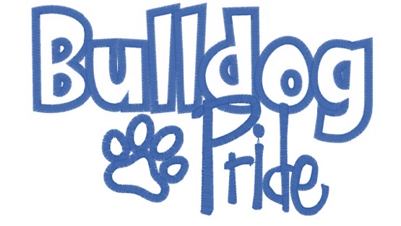
Kindergarten | First Grade | Second Grade
- Pencils – 2 packs of (24)  - 24 ct. of Crayola Crayons – 3  - Fine Point Expo Markers - 1 pack of (4)  - Crayola Classic Color Washable 8-count markers- 1  - Elmer’s Glue Sticks – 12  - Scissors -1 (Fiskars Safety-blunt)  - Package of 100 3x5 index cards –girls only  - Boxes of Tissues – 3  - Napkins or Paper Towels- boys only  - Large Vinyl or Cloth Pencil Bag – 1  - Pack of 3 Large Pink Erasers- 2  - Pack of Copy Paper – 1  - Clorox Wipes – 2  - Large Bottle of Hand Sanitizer –1  - Quart of Ziploc Bags–girls only  - Gallon Ziploc Bags – boys only  Wish List Items  - Card Stock for Classroom use | - Pencils – 4 packs of (24)  - 24 ct. of Crayola Crayons – 4  - Fine Point Expo Markers - 1 pack of (4)  - Elmer’s Glue Sticks – 4-5  - 3 Prong Plastic Pocket Folders – 3 any color  - One Subject (wide-ruled) – 2  - Scissors -1  - Package of 100 3x5 index cards - 1  - Boxes of Tissues – 3  - Pencil Box – 1  - Pkg. of Wide Ruled Loose Leaf Paper- 2  - Pack of 3 Large Pink Erasers- 3  - Pack of Copy Paper – 1  - Clorox Wipes – 2  - Large Bottle of Hand Sanitizer - 1  - Quart of Ziploc Bags–boys only  - Gallon Ziploc Bags–girls only  Wish List Items  Card Stock for Classroom use | - Pencils - 4 packs of (24)  - 24 ct. of Crayola Crayons – 2 boxes  - Fine Point Expo Markers - 1 pack of (4)  - Elmer’s Glue Sticks - 6  - One Subject (wide-ruled) – 3  - Scissors -1  - Boxes of Tissues – 3  - Vinyl Pencil Bag – 1  - Pkg. of Wide Ruled Loose Leaf Paper- 2  - Pack of 3 Large Pink Erasers- 1  - Pack of Pencil Top Erasers- 1  - Pack of Copy Paper – 1 (classroom use)  - Clorox Wipes - girls only  - Quart of Ziploc Bags - girls only  - Hand Sanitizer - boys only  - Gallon Ziploc Bags - boys only  Wish List Items  Card Stock for Classroom use
Additional (required by Art Teacher) Supplies by Grade-Level
1 -24 ct. box of Crayola crayons  1 –sharpened pencil  1 –pink block eraser  1 -large glue stick  1 –additional vinyl or cloth pencil bag to hold  above items (no plastic boxes please).  1 – 8 ct box of Crayola “Classic Colors”  Washable Markers left in the box  Wish list for the Art Room:  Hand and Face Wipes | 1 -24 ct. box of Crayola crayons  1 –sharpened pencil  1 –pink block eraser  1 -large glue stick  1 –vinyl or cloth pencil bag to hold above items (no plastic boxes please).  1 – 8 ct box of Crayola “Classic Colors” Washable Markers left in the box  Wish list for the Art Room:  Clorox/Lysol Disinfecting Wipes | 1 -24 ct. box of Crayola crayons  1 –sharpened pencil  1 –pink block eraser  1 -large glue stick  1 –vinyl or cloth pencil bag to hold above items (no plastic boxes please).  1 – 8 ct box of Crayola “Classic Colors” Washable Markers left in the box  2ndgrade ONLY - 1 white t-shirt  Wish list for the Art Room:  Quart Ziploc Freezer Bags  Gallon Ziploc Freezer Bags

