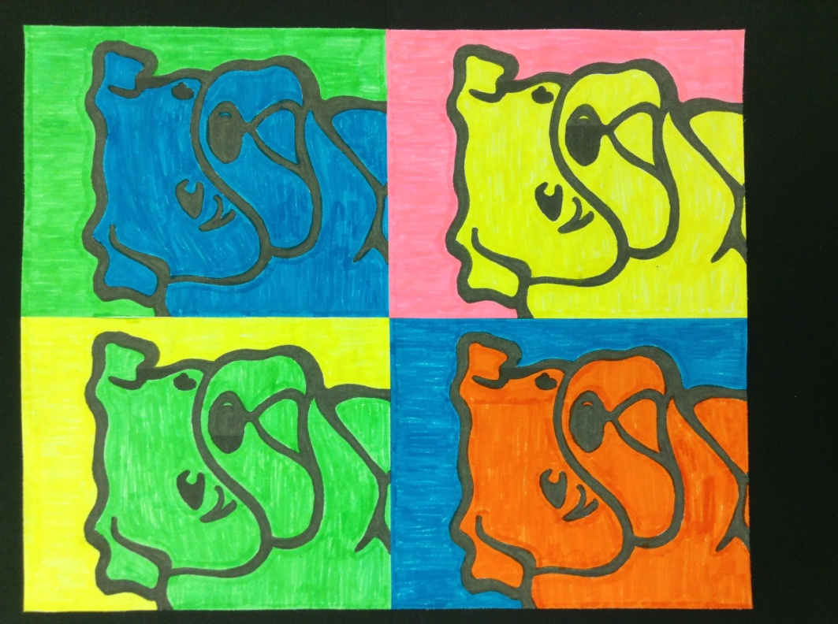
POP ART
BULLDOG
T-SHIRT
T-Shirts are black with the above design printed on the front.

CASH ONLY, PLEASE
Money and order form due no later than Fri. October 7, 2016

Student’s Name:________________________________________________________________
Student’s Teacher/Grade:________________________________________________________

Vancleave Lower Elementary Students may wear these t-shirts on Fridays to show…
BABY BULLDOG SPIRIT!

$10 - Circle Youth Size: XS S M L XL

$12 - Circle Adult Size: XS S M L XL

$14 - Circle Adult Size: 2X

